DBMS PROJECT



HOTEL PRICE COMPARISON

B.Tech 2nd Year

Submitted By:

Saurabh Yadav (U101115FCS143)

Sarthak Kholi (U101115FCS141)

Shiksha Swaraj (U101115FCS212)

Shravya Pagadala (U101115FCS152)

Detailed Discription

Customer satisfaction is all about providing good and fast service and at the same time keeping it simple.

Hotel management system is no different.

Keeping information about all hotels and the keeping it relevant to the need of the customer required a very efficient management of database.

All the information has to be categorised perfectly and make sense to the user.

For this, there need to a web of customer ,administrator and the hotels. Each hotel has a unique id ,name and address. The hotel has several rooms with each room having a unique id,the hotel id ,name and the type of the room.The hotel can own a hall with a unique id ,the hotel rent,type,the hotel id of the hotel. It belongs to and the type of the hotel.The administrator is the supervisor of the reservation being made, he has a unique id, name and a phone number. A customer who needs to make a reservation has a unique id name mobile numberand address. Once reservation is made it has a unique ID the start date and in date of the reservation there is the price of the hall in the room of the hotel updated on daily basis. The today price as a hotel ID, price and the date of the price being tact. That in a straighter confirmed the reservation by checking on the rooms of the hotel but it doesn't get confirm until the payment is done. Once the payment is then the invoices generated by the invoice ID, status and the description. After the completion of the payment the bill is generated with the bill ID, name and the amount. Generation of the bill confirm the reservation.

Detailed ER Diagram

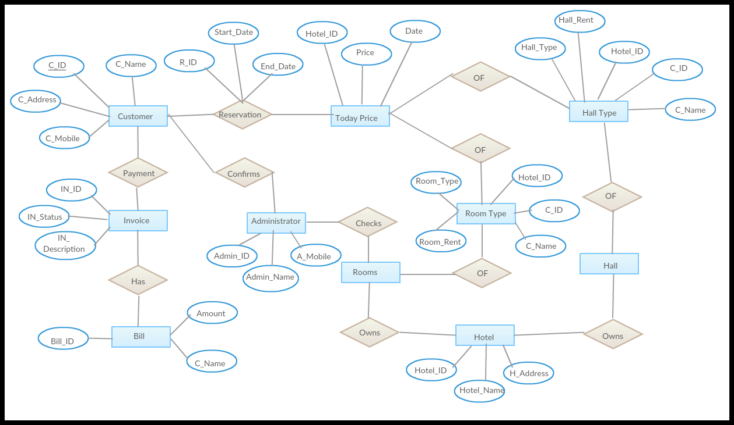

Detailed Procedure to covert the ER Model of Database to Relational Tables

* **TABLE CUSTOMER**

Create table customer(

C_ID number(5) not null,

C_Name varchar(20),

C_Address varchar(20),

C_Mobile number(10),

Primary key (C_ID));

* **TABLE HOTEL**

Create table hotel(

Hotel_ID number(10),

Hotel_Name varchar(20),

H_Address varchar(20),

Primary key (Hotel_ID));

* **TABLE HALL TYPE**

Create table hall type(

Hall_type varchar(20),

Hall_rent number(15),

Hotel_ID number(10),

C_ID number(10),

C_Name varchar(20),

Primary key (hall_type),

Foriegn key (Hotel_ID) references hotel,

Foriegn key (C_ID) references customer,

Foriegn key (C_Name) references customer );

* **TABLE ROOM TYPE**

create table room type(

room_type varchar(20),

room_rent number(15),

Hotel_ID number(10),

C_ID number(10),

C_Name varchar(20),

Primary key (room_type),

Foriegn key (Hotel_ID) references hotel,

Foriegn key (C_ID) references customer,

Foriegn key (C_Name) references customer

)

* **TABLE INVOICE**

Create table invoice(

In_ID number(10) not null,

In_Status varchar(20),

In_Description varchar(30),

Primary key (In_ID)

);

* **TABLE TODAY PRICE**

Create table today price(

Hotel_ID number(10),

Price number(15),

Date,

Foriegn key (Hotel_ID) references hotel

);

* **TABLE BILL**

Create table bill(

Bill_ID number(10) not null,

Amount number(15),

C_Name varchar(20),

Primary key (Bill_ID),

Foriegn key (C_Name) references customer

);

* **TABLE ADMINISTRATOR**

Create table administrator(

Admin_ID number(10),

Admin_Name varchar(20),

A_Mobile number(12),

Primary key (Admin_ID));

Table Schemas

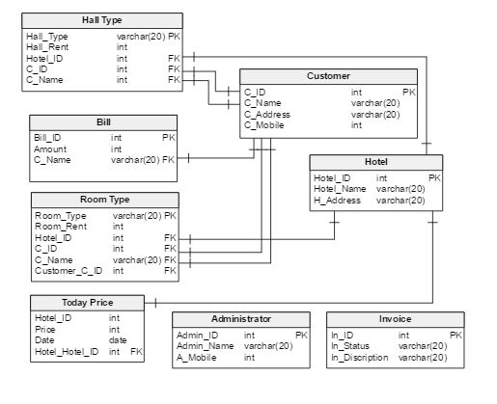

Functional Dependencies

* Table Customer

Schema : {C_ID, C_Name, C_Address, C_Mobile}

Functional Dependencies : {C_ID} → {C_Name}

{C_ID} → {C_Address}

{C_ID} → {C_Mobile}

{C_Name,C_Mobile} → {C_ID}

{C_Name,C_Address} → {C_ID}

* Table Hotel

Schema : {Hotel_ID,Hotel_Name,H_Address}

Functional Dependencies : {Hotel_ID} → {Hotel_Name}

{Hotel_ID} → {H_Address}

{Hotel_Name, H_Address} → {Hotel_ID}

* Table Invoice

Schema : {In_ID,In_Status,In_Description}

Functional Dependencies : {In_ID} → {In_Status}

{In_ID} → {In_Description}

* Table Bill

Schema : {Bill_ID, C_Name, Amount}

Functional Dependencies : {Bill_ID} → {Amount}

{Bill_ID, C_Name} → {Amount}

{C_Name, Amount} → {Bill_ID}

* Table Administrator

Schema : {Admin_Name, Admin_ID, A_Mobile}

Functional Dependencies : {Admin_ID} → {Admin_Name}

{Admin_ID} → {A_Mobile}

{Admin_Name,A_Mobile} → {Admin_ID}

* Table Today Price

Schema : {Hotel_ID, Price, Date}

Functional Dependencies : {Hotel_ID} → {Price}

* Table Room Type

Schema : {Room_Type, Room_Rent, Hotel_ID,C_ID,C_Name}

Functional Dependencies : {Room_Type} → {Room_Rent}

{C_ID} → {C_Name}

* Table Hall Type

Schema : {Hall_Type, Hall_Rent, Hotel_ID,C_ID,C_Name}

Functional Dependencies : {Hall_Type} → {Hall_Rent}

{C_ID} → {C_Name}